**МУНИЦИПАЛЬНОЕ БЮДЖЕТНОЕ ОБЩЕОБРАЗОВАТЕЛЬНОЕ УЧРЕЖДЕНИЕ "ХАЛИМБЕКАУЛЬСКАЯ СРЕДНЯЯ ОБЩЕОБРАЗОВАТЕЛЬНАЯ ШКОЛА ИМЕНИ ГЕРОЯ РОССИИ АСКЕРОВА А.М."**

**Конкурс исследовательских работ и проектов педагогов, учащихся**

**общеобразовательных организаций и воспитанников дошкольных образовательных организаций Республики Дагестан**

**«Науки юношей питают»**

**Исследовательская работа**

**«К олимпийским вершинам»**

**(«To the Olympic peaks»)**

**Автор:**   
Сулейманова Наида Салавутдиновна

ученик 9 «А» класса

МБОУ «Халимбекаульская СОШ

имени Героя России Аскерова А.М.»

Буйнакский район, село Халимбекаул

Контактный телефон: +7(928) 509-62-33

E-mail: [school_2000@bk.ru](mailto:school_2000@bk.ru)

**Научный руководитель:**

Мусаева Хадижат Абузайдиновна

Учитель английского языка,

МБОУ «Халимбекаульская СОШ   
им.Героя России Аскерова А.М.»

Буйнакский район, село Халимбекаул

Контактный телефон: +7(932) 624-37-77

e-mail:xadizhat.musaeva.89@.mail.ru

1. г.

I.Introduction ………………………………………………………………....3 p.

II.Mainpart ……………………………………………………………..……. 4 p.

* 1. 2.1. Earlieryear………………..…………………………...………..4 p.
  2. 2.2. Сareer………………………………………….……….………4 p.

III.Conclusion……………………………………………………………..…..6 p.

IV. Titles and achievements……………...…………………………..….........7 p.

V.Literature …………………………..……………………………..……..... 8 p.

**Introduction**

*«All sports for all people»*

*Pierre de Coubertin.*

People have done sports since ancient times. You can find rock paintings representing some rituals that look like athletic activities. In addition, those rock paintings are 30 thousand years old!

I think people were so interested in sports because they need it in their life. People always wanted to be stronger, healthier and tougher. Therefore, in Ancient Greece there was a tradition to hold the Olympic Games.

A few words about the Olympic Games, the Olympic Games is the largest comprehensive international sports competitions, which is held every four years.

**(Application 1)**

By the way, the tradition of the Olympic Games, which existed in Ancient Greece, was born as part of a religious cult. Games were from 776 BC at 393 A.D (there were 293 Olympics in Olympia, considered among Greeks a sacred place.) The name of the Game was formed From Olympia.

The modern Olympic games was revived in the late nineteenth-century French social scientist Pierre de Coubertin.

Olympic Games are held every four years since 1896.Two weeks after the Olympic Games, Paralympic games is held for people with disabilities.

**The purpose of my work:** To beacquainted with the history of an athlete who has reached unprecedented heights.

**Task:**

* Give an idea of the sport;
* To introduce Muslim Salikhov;
* Cultivate a love of sports and achieve your goals. Cause feelings of pride to all who glorify our Homeland.

**II. Mainpart**

**2.1. Earlier year**

Now I want to tell you about my countryman-an outstanding person who is known not only in my native Dagestan, but also throughout Russia and abroad, he is the winner of the Olympic tournament, and has reached unprecedented heights in sports.

Muslim Magomedovich Salikhov was born on June 9, 1984. He joined the USHU-SANDA section at the age of nine. He is a five-time world champion, three-time European champion, winner of the Olympic tournament in Beijing, winner of the world games in USHU-SANDA, holder of the official title "King of Kung Fu". According to the rules of MMA, Muslim won seven fights. He is a graduate of the faculty of physical culture and sports of DGPU and the Rostov Institute of national economy. He is married and has two children. **(Application 2)**

**2.2. Сareer**

The sports path of the famous champion began at an early age, when the young man in the distant 1995 came to school of martial arts "Five sides of the world" known today all over the world, under the guidance of the famous coach Hussein Magomayev.

The first successes were not long in coming. Muslim began to win awards of various scales. As recognized by the athlete for the entire sports career, the most memorable tournament was the international tournament held in 2006. An unqualified victory in which gave Muslim the title of "King of Kung Fu". He is still the only non-Chinese citizen to hold this title. **(Application 3)**

According to the English proverb: “Easy come, easy go’’But it is not about him. Because, every victory gets him not easily. Nevertheless, he has so many victories, that many sportsmen only dream of it. He has reached such sports titles, some of them are unique: mainly he is the only Olympic champion in this sport as USHU-SANDA. He is the only "King of Kung Fu" not Chinese. So far, the winner of the crown were the Chinese, and no foreigner was not the owner of the Royal crown.

However, even to Hussein Magomayev’ surprise, the first fight Muslim proved that he had all the chances to become king.  
The first fight Muslim fought with an opponent in his weight - 80kg.The beginning of the fight did not promise anything good to our fellow countryman.

However, during the fight, desperation in his victory, Hussein suddenly saw another Muslim.

Maybe, just this moment Hussein discovered the true Muslim.   
Amazed trainer, picked up the phone and overenjoyed shouted into the phone, listening to his wife Olga: «I don’t recognize Muslim. He is like a leopard, falls and crushes his opponent».

The fight lasted 6 minutes. So, he won the 2nd fight, the 3rd and the 4th main. Here is Winning! Here is – the Crown!

Could parents imagine that little Muslim, when in 1984, a boy was born, that would show the world the future king, whom he became due to his hardworking, skill, professionalism. He snatched the crown from the hands of the Chinese athlete, king of kung Fu which was heavier than Muslim.

No one, including the master Hussein, «the Teacher» how would call him in the East, could not forest the outcome of the world champion ship, to which the 8strongest athletes of the world were invited.

Of course, our fellow citizens: B. Ataev, D. Beletov and others could participate in this tournament.

You can see the professional skills of Muslim did not cause any concern on the part of the organizers of the tournament and they were sure that one of the eight Chinese athletes would be awarded the Crown of the King. **(Application 4)**

Along with performing under USHU-SANDA rules, Muslim held professional fights under Kickboxing rules. Salikhov has long won every possible USHU-SANDA title. Having reached unprecedented heights in this sport, he began to practice MMA professionally in 2011, while successfully continuing to compete in USHU competitions.

In 2013, the athlete took first place in the world games, at the age of 33 in 2017, signed a contract with the UFC. **(Application 5)**

**III.Conclusion**

Today, Salikhov often trains in the United States and other countries. He speaks English very well. It is also worth noting that all athletes from the school "Five sides of the world" are modest and Muslim is no exception. Having great achievements in sports he has a modest character. **(Application 6)**

**IV. Titles and achievements**

What successes were achieved by Muslim ‘young Cup/ In 1997 M. Salikhov for the first time he participated«Young dragon» in Moscow, where he takes 2nd place of category up to 42 kg, after what he earned the nickname «the Dragon» from this period his fighting career began.   
In 2003, the Championship of Russia held, in Moscow, he takes the 1st place.   
In 2004 Moscow. He becomes European champion. In the same year he becomes the champion of Russia.   
In 2005 in Vietnam in the city of Hanoi he becomes World Champion.  
2007-World champion in China.  
2008-Champion of the Olympic tournament Pekin 2008’’.   
2009-World champion in Canada.  
2010-Winner of the «Golden belt» in the nomination «the Best sportsman of the year».  
2011-World champion in Turkey.  
In 2012 he has joined to MMA(Mixed Martial Arts).  
2013-the fight of MMA’s champions in St. Petersburg. He takes the first place.  
2014-December.China.Again he is winner.  
2015-Soon he will fight in Argentina on the 15th of April. Now he is in Brazil.  
19 October, he signed a contract with the UFC and on November 25,2017 at the UFS lost a painful reception in his first fight.  
2018-won against American Ricky Rainey.  
2020-oderjal victory, which allowed him to reach a series of victories. He holds seminars in China, Italy and Russia, and gives, master classes. He speaks English very well.

Muslim! We wish your health, success and reach all heights not only in sports but also in your personal life! Muslim, be a good example for today’s young generation, not only as a talented athlete, but also as a real man! **(Application 7)**

**IV.Literature**

1. Salikhov M. M. History of the King of Kung Fu [Electronic resource]

Mode of access: <http://www.history.ru/>

1. Salikhov M. M. statistics of professional fights on the Sherdog website [Electronic resource]

Modeofaccess: <https://www.sherdog.com/>

Application 1

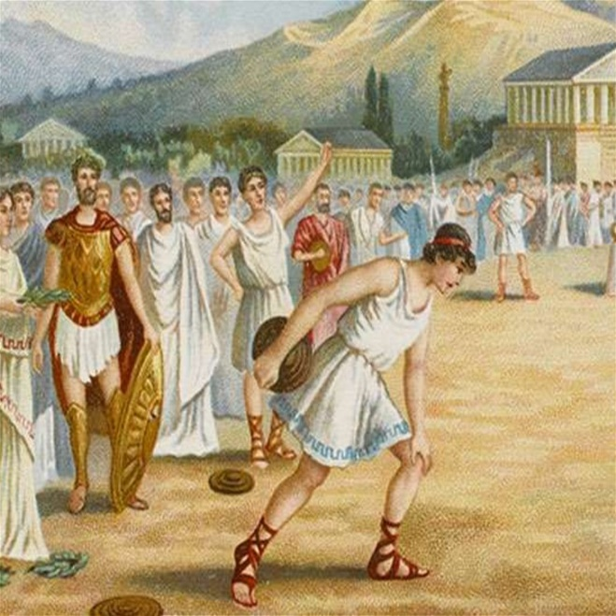

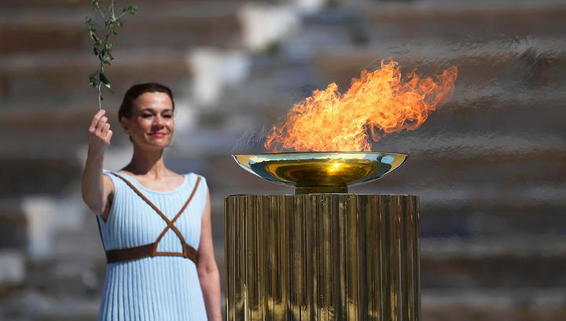

Application 2

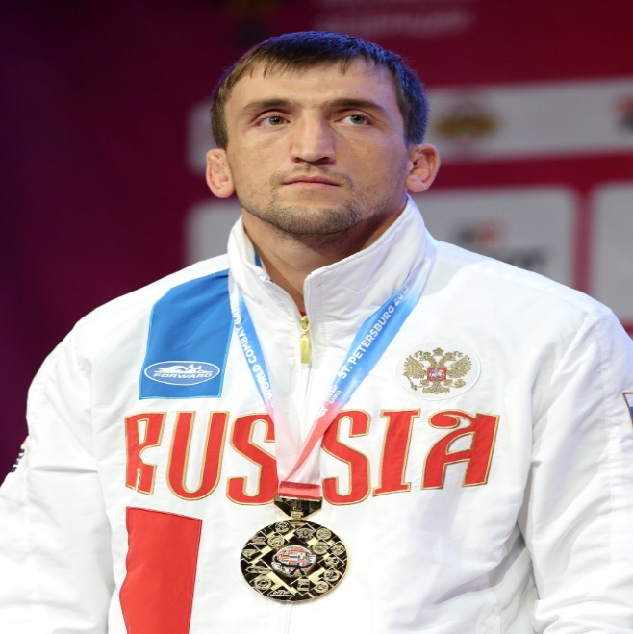

Application 3

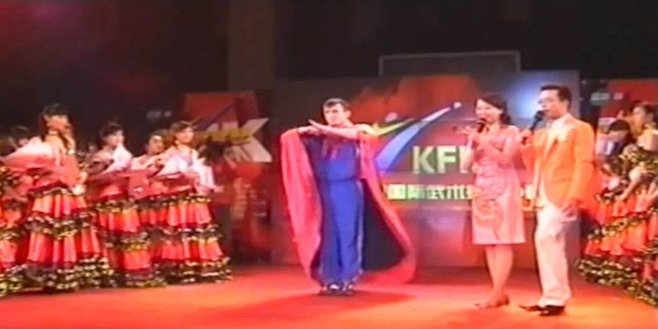

Application 4

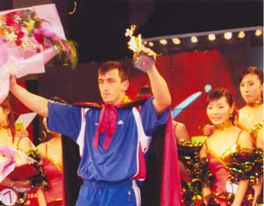

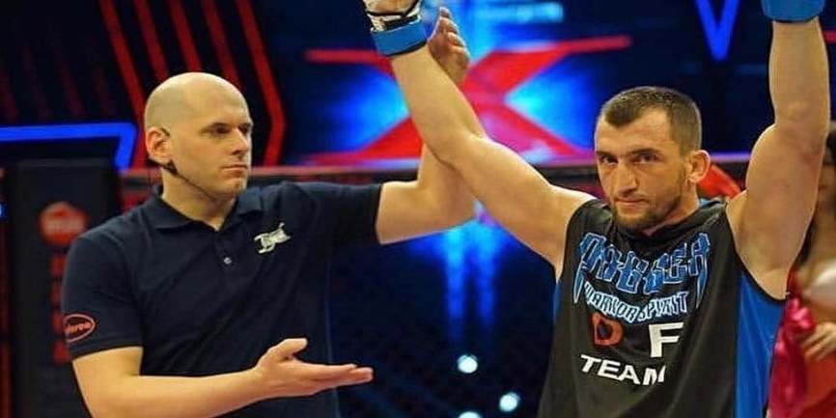

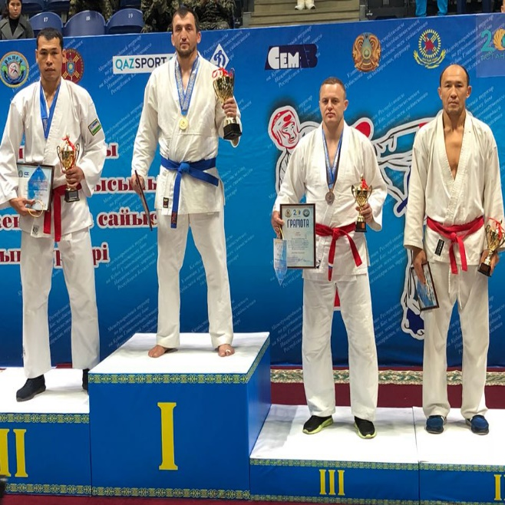

Application 5

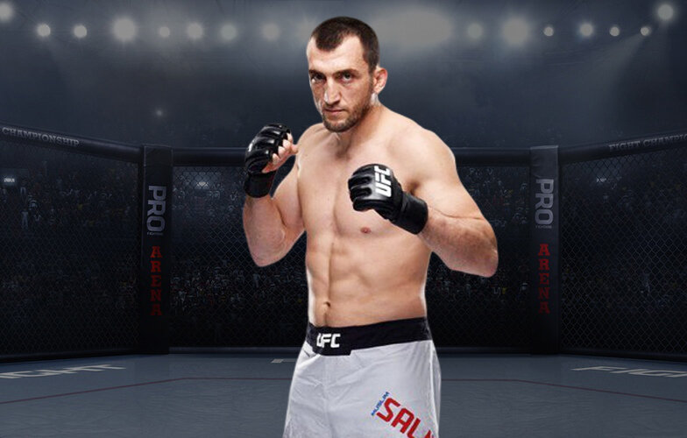

Application 6

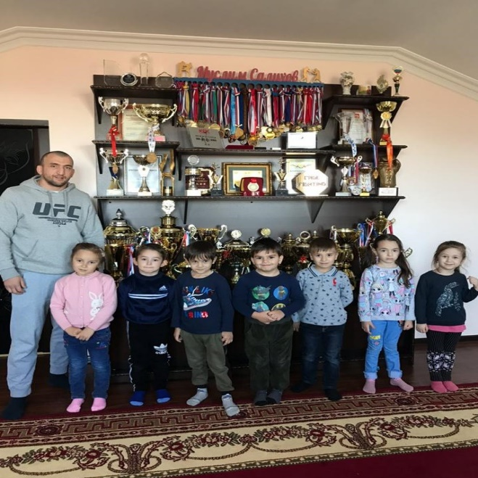

Application 7

